Sheila Morcombe
Higher Education Fund
Bursary Scheme Application Form


Please ensure that you are a Chalkhill resident living within the CCTF area of benefit (refer to the map at the bottom of the form) and carefully read all the information before completing this form.
Further information about the application process is available at www.chalkhillcommunitytrustfund.co.uk. You will also need to read the Chalkhill Community Trust Fund’s (CCTF) Funding Criteria and Guidelines before completing the application form. Remember to supply all the additional documentation that is requested.

DEADLINE – Please note, the trust accepts applications from January until 31st August for commencement in September the same year.

NOTIFICATION - will only be sent out to applicants via email between end of September and the start of October.

SUPPORTING EVIDENCE
Please use this check list as a guide and easy reference as you prepare to complete the application. You will need to provide evidence of the following:
- Proof of address (please see list below)
- Proof of identity (please see list below)
- Proof of bank account
- Conditional Offer Letter from Higher Education Institution/University

Your application will not be considered until you have submitted all the required evidence.

Proof of name | Proof of address
Current signed passport | Utility bill (gas, electric, satellite television, landline phone bill) issued within the last 3 months
Original birth certificate (UK birth certificate issued within 12 months of the date of birth in full form including those issued by UK authorities overseas such as Embassies High Commissions and HM Forces) | Local authority council tax bill for the current council tax year
EEA member state identity card (which can also be used as evidence of address if it carries this) | Current UK driving licence (but only if not used for the name evidence)
Current UK or EEA photocard driving licence | Bank, Building Society or Credit Union statement or passbook dated within the last three months
Full old-style driving licence | Original mortgage statement from a recognised lender issued for the last full year
Photographic registration cards for self-employed individuals in the construction industry -CIS4 | Solicitors letter within the last three months confirming recent house purchase or land registry confirmation of address
Benefit book or original notification letter from Benefits Agency | Council or housing association rent card or tenancy agreement for the current year

PLEASE WRITE IN CAPITAL LETTERS
Please ensure you meet eligibility criteria before applying and that you have all the necessary documentary evidence. Your application will not be considered if you are not eligible or if any evidence is missing.

1. Applicant Details

(a) Applicant details

Name
Date of Birth
Address & Post Code

Phone
Email

(b) How did you hear about this scheme?

Chalkhill Community Centre
Metropolitan Thames Valley
CCTF’s Website
Web search
Email
CCTF’s Facebook page
Other, please specify details below.

(c) Have you applied for or been offered a place on a higher education or degree programme?

Yes No

(d) Have you applied for or Chalkhill Community Trust Fund Higher Education bursary before?

Yes No

If yes, please give details.

(e) Bank or Building Society details
To receive payments, you must have a bank account in your own name. If you do not have a bank account, you need to open one before completing this form.

Name of Account Holder
Name of Bank
Bank Branch Address

Sort Code
Account Number

2. Course Details

- Course details

Attach evidence e.g. a Conditional Offer Letter from the University/Higher Education Institution.)

Course Title

Name of University or Higher Education Institution

(b) Level of study
Please tick to specify level:
Undergraduate degree
Foundation degree
Higher education degree equivalent
Other – please provide details below

(c) How long is your course?
(Specify the number of years your course lasts)

(d) Career intentions - please explain the industry or type of career that you would like to pursue.
(You may attach additional information – maximum 200 words)

3. Personal Statement

- Please state the reasons why you are seeking financial support from the Higher Education Fund?

Please ensure you provide details and explain:
- What you will spend the money on,
- How your application meets the funding criteria, and
- How you will give back/contribute to the Chalkhill Community.

(Please write no more than 1,000 words)

(see continuation sheet)
- Additional information
(Please give details of any additional information you would like to provide to support your
application, maximum 200 words)

- Availability for telephone interview
Trustees may invite Applicants to a selection interview. Do you agree to a tele-conference/interview?

Yes No

Preferred day for call
Preferred time of day for call (specify morning/evening)

4. Checklist.

Your application will only be considered after all the information has been received. All supporting documentation must be received by 7th July 2018.

Please mark as appropriate:
Completed all sections of the Application Form
Proof of Address
Personal statement
Proof of conditional offer e.g. Letter from university or Higher Education Institution
Proof of Identification
Proof of Bank Account

5. Declaration, eligibility confirmation and consent for publicity

5.a Eligibility

Do you meet the Chalkhill Community Trust Fund Higher Education Fund eligibility criteria which can be found at www.chalkhillcommunitytrustfund.co.uk

Yes No

5.b Keeping in touch with us and publicity

Should your application be successful, do you agree to keep in touch with the Chalkhill Community Trust Fund and agree to take part in any publicity that may arise as a result of your selection for an award? If you cannot commit to keeping in touch with the Chalkhill Community Trust Fund please do not apply.

Yes No

5.c Commitment to volunteering or community development

Should your application be successful, do you agree to take part in 20 hours per year of voluntary work in the Chalkhill Community? This could be volunteering at the annual Chalkhill Day Celebration or summer play scheme events or volunteering at the Chalkhill Community Centre etc.
If you cannot commit to taking part in volunteering, do not apply.
If you do not commit to 20 hours of volunteering per year, you may be asked to pay back any funds received or your application will be put on hold and you will not receive any more payments from the CCTF.

Yes No

6.d Declaration of Interest

The Chalkhill Community Trust Fund is made up of members of the Chalkhill Community. You can still apply if you know or are associated with Trustees or associated with the Chalkhill Community Trust Fund as long as your association is declared.

Do you know any of the Trustees or anyone associated with Chalkhill Community Trust Fund?

Yes No

6.e Declaration of Truth and Agreement Terms

In making this funding application I understand and declare that:

- Any false or misleading information is provided, funds will be recovered, and no further funds will be disbursed.
- To the best of my knowledge the information contained herein is true and correct.
- Any funding received will be used for the purpose for which it was approved and if this is not the case the full amount is to be returned to the Chalkhill Community Trust Fund.
- After the first year of study, if I choose to go onto a different course, continued payment of the grant is at the complete discretion of the Higher Education Committee.
- At any point/time that I stop the course/studying I must contact the Chalkhill Community Trust Fund immediately or money will be recovered.
- I will comply with any reasonable request from the Chalkhill Community Trust Fund to monitor my academic performance and attendance.
- At the end of each academic year you must provide evidence/confirmation that you will be continuing studies (email/letter from University)
- I acknowledge that any decision made by the Chalkhill Community Trust Fund is final. I accept that no reasons for such decision will be given, nor will any correspondence be entered into.

Signature: | Date:

Please email: Aminata on CCTFcontact@gmail.com if you require any assistance with your application.

Completed applications and relevant documentation should be emailed to: CCTFcontact@gmail.com
#
MM

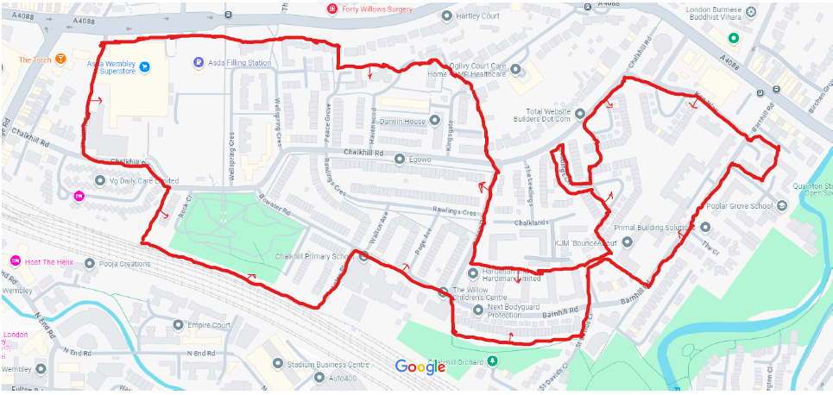
Map of the CCTF Area of Benefit

