
Back to School Scheme
Application Form

This is a one-off grant of up to £150 provided by the Chalkhill Community Trust Fund (CCTF) to assist in purchasing uniform for the children of Chalkhill (within CCTF’s area of benefit, please refer to the map attached below). CCTF understands the high cost of school uniforms and that some parents may be experiencing financial challenges as the cost of living continues to increase.
What you will receive:
The offer is £50 per child/young person, for households with 1 or 2 children/ young people. Families with 3 or more children will only receive £150. The maximum award per household is £150.
To apply, please complete in Block Letters all sections of the form below in addition to the supporting evidence (proof of address such as council tax, utility bill, etc; a copy of any ID of the child or children whom you are applying for). We are unable to consider incomplete forms. Please note the award will be in the form of a cheque which must be deposited into your bank account within 30 days of receipt. Please note this scheme is open from Monday 20th April to Sunday 31th May 2026.
Name of Parent/Career (as it appears on your bank account):
Your Address and Postcode (with the name of the Block if applicable):

Your Contact number:
Email address:
How many children are in the household in primary or secondary school up to year 13 (aged 18)?
Please confirm by providing the name, age of each child and which school they attend:
Name | Age | School & Year the child will be in September
Child 1
Child 2
Child 3
Child 4
Child 5

Eligibility Criteria: Should live in Chalkhill within CCTF’s area of benefit and attend primary school up to sixth form/college (please refer to the map attached below)

Print name: Signature:
“Turn over to continue”
Date:

For Confidentiality Purposes
The information will be treated sensitively and confidentially. The information is needed strictly to process the application and provide the award. It will be restricted to the Chalkhill Community Trust Fund team.

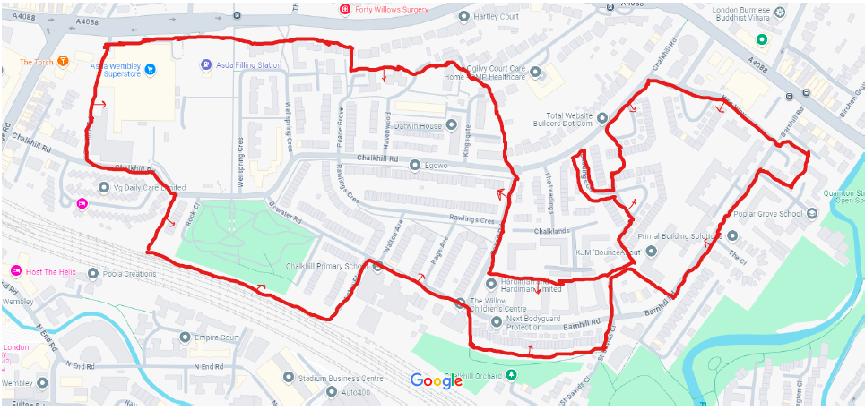
CCTF’s Area of Benefit-Map

